Lab 11 – My Solutions
1: Exercise: Zone Configuration:
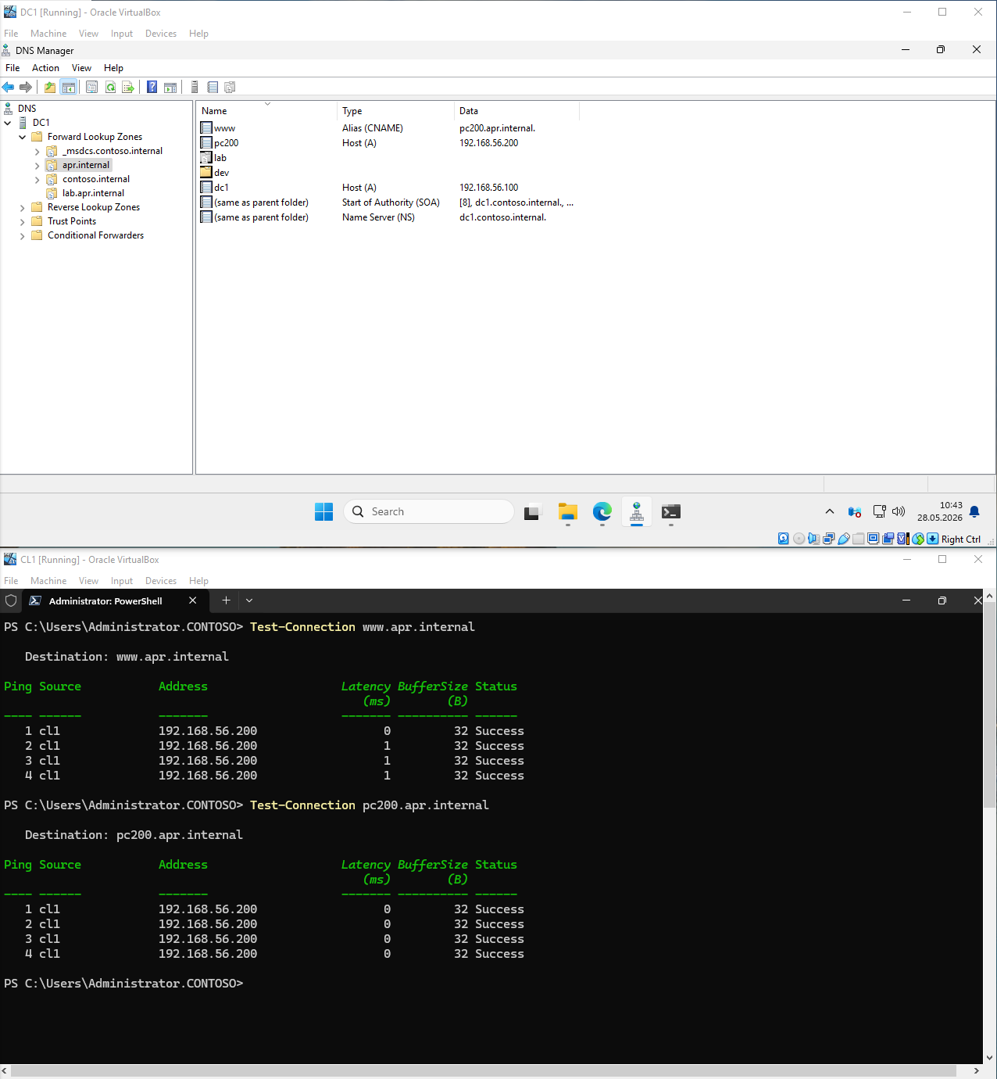
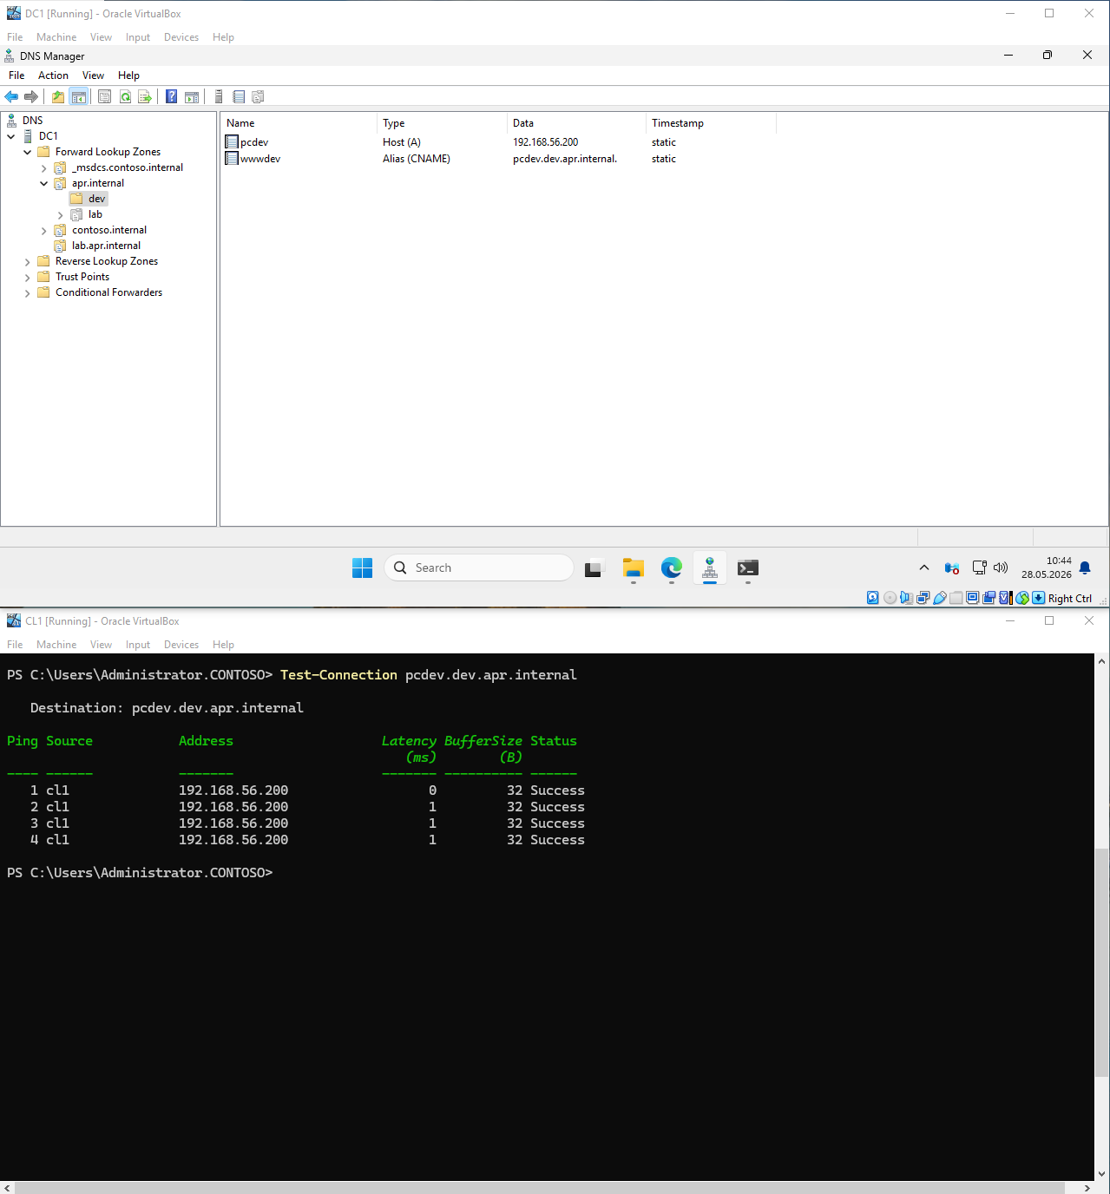

2: Exercise: Zone Delegation:
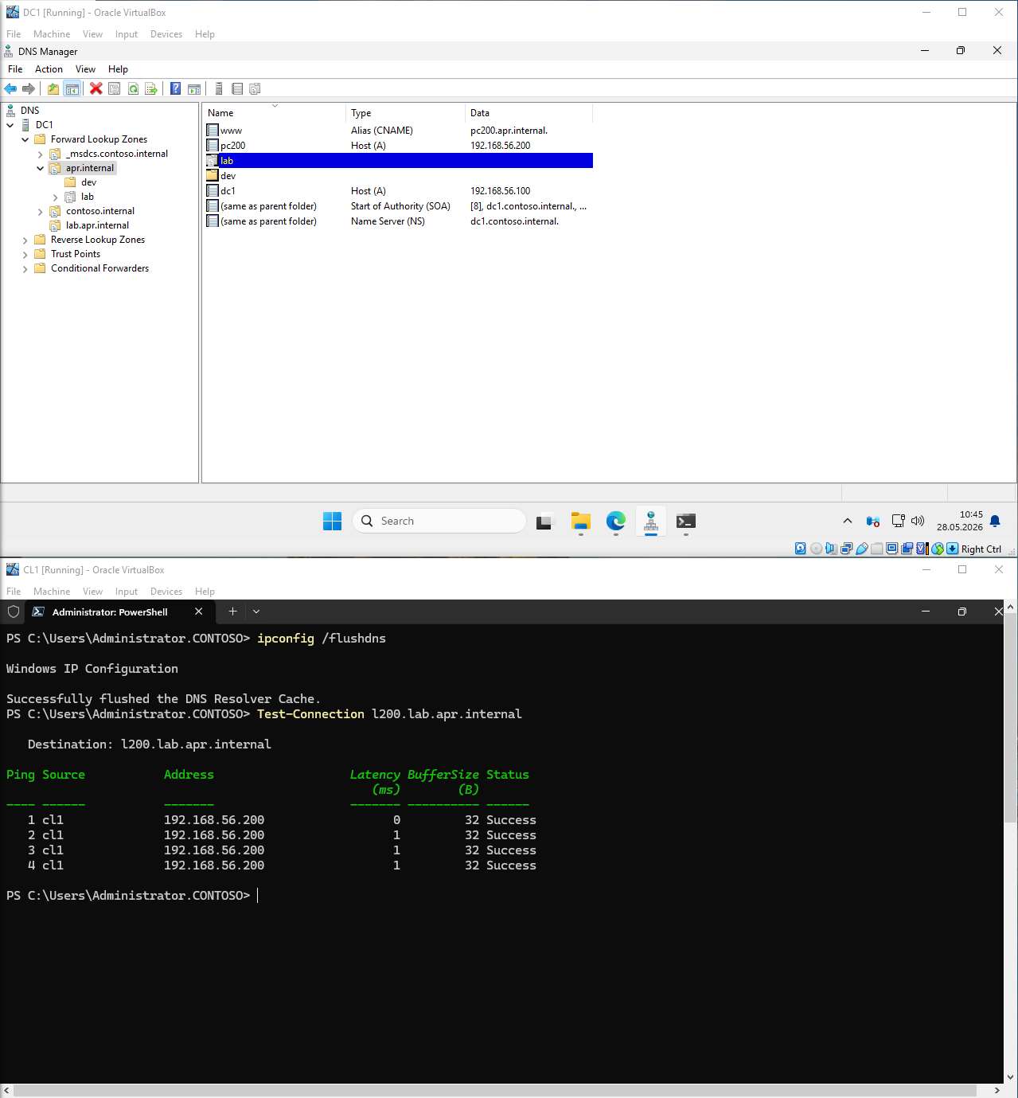
3: Exercise: The hosts File:
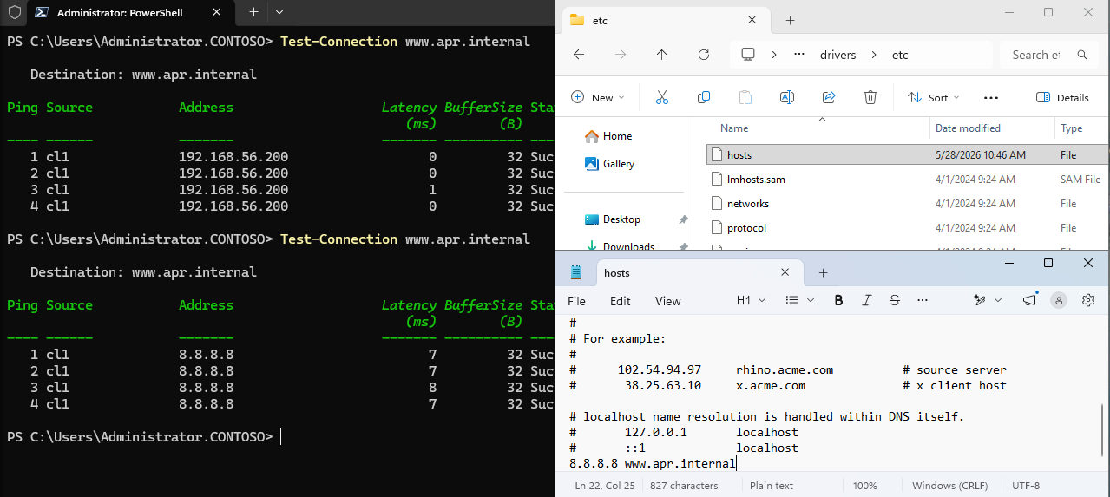

4: Exercise: DNS and Active Directory:
Navigate to: DNS console → DC1 → _msdcs.contoso.internal
Record path | What it contains | Meaning
_tcp.dc._msdcs.contoso.internal | SRV records for all Domain Controllers | Clients use this to find any DC for Kerberos/LDAP authentication
_tcp.pdc._msdcs.contoso.internal | SRV record for the PDC Emulator | Points to the single DC holding the PDC Emulator FSMO role (handles password changes, time sync, legacy NT clients)
The entire _msdcs zone is auto-populated by AD DS — it's how clients, DCs, and replication all discover each other without manual configuration. Every time a DC starts, it re-registers its SRV records here.
